H AR U MI

K OB AY AS H I

ART DIRECTOR

EXPERIENCE

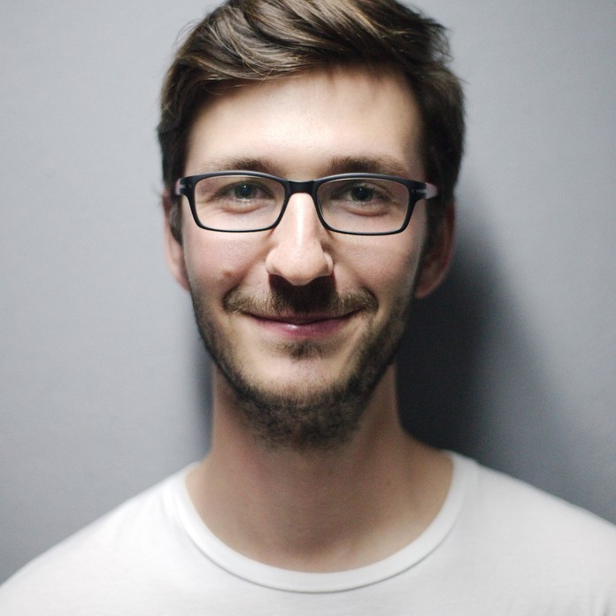Senior Graphic Designer

Aldenaire & Partners // 2013 - 2016
Corporate with deisgners to create content and visual branding. Develop project concepts.

Senior Graphic Designer

Fouget // 2016 - 2019
Reviewing and approving designs, artwork and other components of a project

Art Director

Studio Shodwe // 2019 - 2021
Reviewing and approving designs, artwork and other components of a project

EDUCATION

Borcelle University
Bachelor of Arts // 2010 - 2015

Warner & Spencer University
Masters of Arts Communication // 2008 - 2010

Thynk Unlimited
Digital media and user experience // 2006 - 2008

Larana, Inc
Cinematics and photography // 2006 - 2008

CONTACT ME

Addres
123 Anywhere St., Any City, ST 12345

Phone
123-456-7890
+123-456-7890

Website
hello@reallygreatsite.com

PRO SKILLS

Photoshop

Illustrator

